**machine learning engineer (ML engineer)**



By

* [**Alexander S. Gillis,**](https://www.techtarget.com/contributor/Alexander-S-Gillis)Technical Writer and Editor

**What is a machine learning engineer?**

A machine learning engineer (ML engineer) is a person in IT who focuses on researching, building and designing self-running artificial intelligence ([AI](https://searchenterpriseai.techtarget.com/definition/AI-Artificial-Intelligence)) systems to automate [predictive models](https://searchenterpriseai.techtarget.com/definition/predictive-modeling). Machine learning engineers design and create the AI algorithms capable of learning and making predictions that define machine learning ([ML](https://searchenterpriseai.techtarget.com/definition/machine-learning-ML)).

An ML engineer typically works as part of a larger data science team and will communicate with data scientists, administrators, data analysts, [data engineers and data architects](https://searchdatamanagement.techtarget.com/feature/Data-management-roles-Data-architect-vs-data-engineer-others). They may also communicate with people outside of their teams, such as with IT, software development, and sales or web development teams, depending on the organization's size.

ML engineers act as a bridge between data scientists who focus on statistical and model-building work and the construction of machine learning and AI systems.

The machine learning engineer role needs to assess, analyze and organize large amounts of data, while also executing tests and optimizing machine learning models and algorithms.

**Roles and responsibilities of a machine learning engineer**

An ML engineer's primary goals are the creation of machine learning models and retraining systems when needed. Responsibilities vary, depending on the organization, but some common responsibilities for this role include:

* Designing ML systems.
* Researching and implementing [ML algorithms](https://whatis.techtarget.com/definition/machine-learning-algorithm) and tools.
* Selecting appropriate data sets.
* Picking appropriate data representation methods.
* Identifying differences in data distribution that affects model performance.
* Verifying [data quality](https://searchdatamanagement.techtarget.com/definition/data-quality).
* Transforming and converting data science prototypes.
* Performing [statistical analysis](https://whatis.techtarget.com/definition/statistical-analysis).
* Running machine learning tests.
* Using results to improve models.
* Training and retraining systems when needed.
* Extending machine learning [libraries](https://searchsqlserver.techtarget.com/definition/library).
* Developing machine learning apps according to client requirements.

**Skills and qualifications to become a machine learning engineer**

To become a machine learning engineer, an individual should have experience with these skills and qualifications:

* Advanced math and statistics skills, surrounding subjects such as linear algebra, calculus and [Bayesian statistics](https://whatis.techtarget.com/definition/Bayesian-statistics).
* Advanced degree in computer science, math, statistics or a related degree.
* Master's degree in machine learning, neural networks, [deep learning](https://searchenterpriseai.techtarget.com/definition/deep-learning-deep-neural-network) or related fields.
* Strong analytical, problem-solving and teamwork skills.
* Software engineering skills.
* Experience in data science.
* Coding and programming languages, including Python, Java, C++, C, [R](https://searchbusinessanalytics.techtarget.com/definition/R-programming-language) and JavaScript.
* Experience in working with ML frameworks.
* Experience working with ML libraries and packages.
* Understand [data structures](https://searchsqlserver.techtarget.com/definition/data-structure), data modeling and software architecture.
* Knowledge in computer architecture.

**ML engineer salary and job demand**

In 2019, Indeed ranked machine learning engineer as [the No. 1 job](https://www.forbes.com/sites/louiscolumbus/2019/03/17/machine-learning-engineer-is-the-best-job-in-the-u-s-according-to-indeed/?sh=339d71067bb0) in the U.S. The same role was ranked within the top three positions in other, similar polls that year. Around that time, [Gartner](https://whatis.techtarget.com/definition/Gartner) also reported organizations tend to struggle with AI initiatives due to lack of technical skills, process, tooling and lack of know-how in deploying ML models, which also explains the role's demand.

As of 2021, Indeed states the average base salary for an ML engineer in the U.S. is $149,801 per year, while Glassdoor states the average salary is lower at $127,326 per year.

**Machine learning engineer vs. data scientist**

Machine learning engineer and data scientist roles are similar, considering both positions tend to include handling large amounts of data, require certain qualifications and use similar technologies. However, where ML engineers focus on creating and managing AI systems and predictive models, data scientists extract meaningful insights from large data sets.

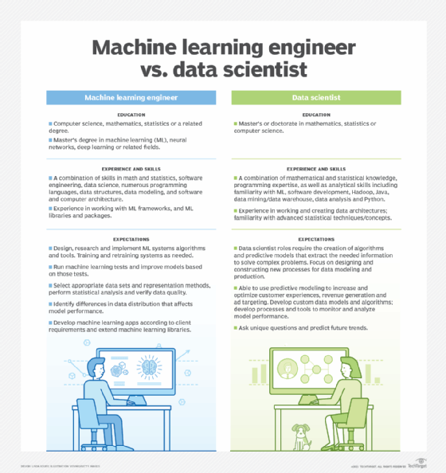

Review the differences between machine learning engineers and data scientists.

A data scientist is responsible for collecting, analyzing and interpreting extremely large amounts of data. The large amounts of data are used to develop hypotheses, inferences and analyze customer or market trends. This position requires the use of advanced analytics technologies, including predictive modeling and machine learning techniques, as well as skills in mathematics, statistics, [cluster](https://whatis.techtarget.com/definition/cluster) analysis and visualization.

Other basic responsibilities of a data scientist include using various types of analytics and reporting tools to detect patterns, trends and relationships in data sets.

Machine learning engineers and data scientists will work in close collaboration with each other, and both require sufficient data management skills.

This was last updated in April 2021

**Continue Reading About machine learning engineer (ML engineer)**

* [Merging DevOps and machine learning requires restructuring](https://searchenterpriseai.techtarget.com/feature/Merging-DevOps-and-machine-learning-requires-restructuring)
* [9 types of machine learning algorithms with a cheat sheet](https://searchenterpriseai.techtarget.com/feature/5-types-of-machine-learning-algorithms-you-should-know)
* [In-depth guide to machine learning in the enterprise](https://searchenterpriseai.techtarget.com/In-depth-guide-to-machine-learning-in-the-enterprise)
* [How to build a machine learning model in 7 steps](https://searchenterpriseai.techtarget.com/feature/How-to-build-a-machine-learning-model-in-7-steps)
* [Data science vs. machine learning vs. AI: How they work together](https://searchbusinessanalytics.techtarget.com/feature/Data-science-vs-machine-learning-vs-AI-How-they-work-together)

**Related Terms**

[**machine learning**](https://searchenterpriseai.techtarget.com/definition/machine-learning-ML)

Machine learning (ML) is a type of artificial intelligence (AI) that allows software applications to become more accurate at ...[See complete definition](https://searchenterpriseai.techtarget.com/definition/machine-learning-ML)

[**reinforcement learning**](https://searchenterpriseai.techtarget.com/definition/reinforcement-learning)

Reinforcement learning is a machine learning training method based on rewarding desired behaviors and/or punishing undesired ones.[See complete definition](https://searchenterpriseai.techtarget.com/definition/reinforcement-learning)

[**What is artificial intelligence?**](https://searchenterpriseai.techtarget.com/definition/AI-Artificial-Intelligence)

Artificial intelligence is the simulation of human intelligence processes by machines, especially computer systems. Specific ...[See complete definition](https://searchenterpriseai.techtarget.com/definition/AI-Artificial-Intelligence)